GBDF Winter Masters
Competition 2018
Invitation

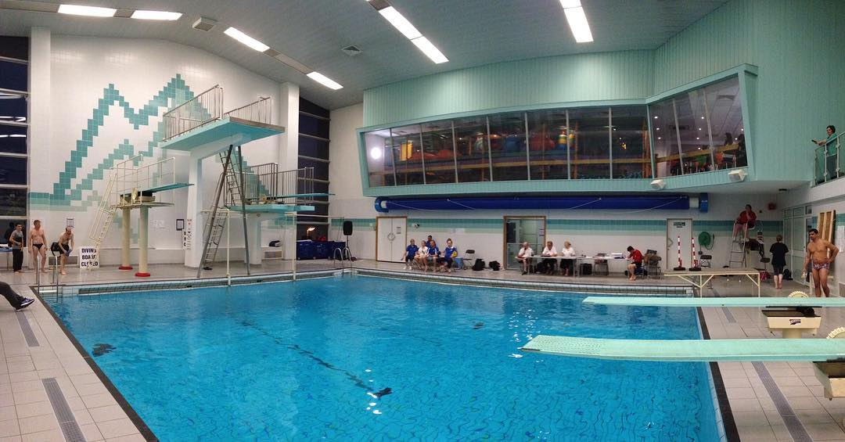

For Masters divers and Novice Masters divers

November 9th 10th & 11th 2018

Tunbridge Wells Sports Centre
St John’s Road
Tunbridge Wells
Kent TN4 9TX

WINTER MASTERS CHAMPIONSHIPS 2018
AGE GROUP | CONDITIONS
16 – 29  30 – 39  40 – 49  50 – 59 | 6 different dives (No repeats) from a minimum of 4 groups, no tariff restriction. Must use 3 different heights of board (1m Platform & 3m Platform excluded).
60 - 69 | 5 dives from a minimum of 3 groups, no tariff restriction. Must use at least 2 boards of different heights (1m Platform & 3m Platform excluded). May repeat one dive for a tariff of 1.0
70+ | 4 dives from a minimum of 2 groups. Must use at least 2 boards of different heights (1m Platform & 3m Platform excluded). May repeat two dives for a tariff of 1.0.

WINTER NOVICE CHAMPIONSHIPS 2018
AGE GROUP | CONDITIONS
16 – 29  30 – 49  50+ | 4 different dives from a minimum of 2 groups. Must use at least 2 boards of different heights from 1m springboard, 3m springboard or 5m platform. Maximum number of rotations is 1.5 in any direction.  Under 50 may repeat one dive at 1.0 tariff.  50+ may repeat up to two dives at 1.0 tariff.

SYNCHRO COMPETITION 2018
The synchro event will be run as one event using 1m Springboard, 3m Springboard, or 5m platform. You can use any mix of boards or just stick to one, your choice.

3 rounds of dives. 1 must be in opposing direction (i.e.101b & 401b) No tariff limit.

Single sex pairs or mixed pairs are permitted.

FUN COMPETITION 2018

AGE GROUP | CONDITIONS
16 – 29  30 – 49  50 – 69 | 3 Different Dives, all entries must be Feet First, must use 2 heights of board, No Repeats. Standard tariff applies.
70 - 74 | 3 Dives, all entries must be feet first, 1 repeat allowed. Any board(s) but excluding 1m Platform & 3m Platform. Standard tariff applies.
75 and over  In 5 year increments | 3 different jumps.  Dive 1 10 (forward jump) A, B or C  Dive 2 20 (back Jump) A,B or C  Dive 3 any different jump from the above  Any board/s to be used

THE CHALLENGE OPEN

AGE GROUP | CONDITIONS
All ages will dive together | The Challenge - This is being done as divers have requested that they are allowed to challenge themselves. This could progress in future years giving the more adventurous divers something to work towards.  This will be a 3 dive competition which will be Men and Women Diving together. All dives will be 1.0 DD. All ages allowed to enter.  At the beginning of each round a dive will be picked out of the hat all divers will perform that dive.  Dives in the hat-  202A, 104B, 5122, 5124, 5221, 5231, 5223, 5321

All divers must be 16 years of age on or before 10th November 2018.
Any dives with the same number but different position, or from a different height are classed as a repeat. (Except the 75 – 99 age groups)
Dives without rotation (jumps) (dive no. x00) may not be used. This does not apply to 600A used on Platform as it is a recognised FINA dive. This applies to all competitions. (Except the fun competition)
Divers who are currently competing in all ASA National Competitions may not compete in the Masters events, except to dive as a guest.
Entries from divers aged 16/17 years old MUST be accompanied by a letter signed by the Welfare Officer, or other responsible official of the diver's club, stating that they will ensure that child protection procedures will be followed and that the diver will be appropriately chaperoned for the duration of the event.
Entry Information
Entry fee will be £12 per start and £12 per Synchro Pair

Important dates:

Friday 14-09-2018 Entries open

Saturday 13-10-2018 Entries Close

Saturday 3-11-2018 Last day to submit/change dive via Dive Recorder

Saturday 10-11-2018 1st competition day

Sunday 11-11-2018 2nd competition day

If there is sufficient space after the closing date for entries late entries may be accepted up until 3rd November 2018 however a late entry fee will be applied.

Payment Information :
Payment can be made by BACs, account number 40557838, sort code 20-06-09. Please quote Winters Masters and your name.
Cheques accepted with Entry form also accepted, please make payable to ‘Great Britain Diving Federation’.

